PPT newly developped items
1 Frog Tadpole Lion
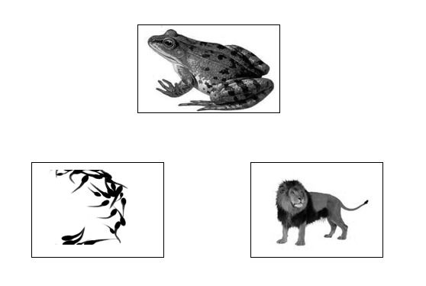
2 Envelope Stamp Camera
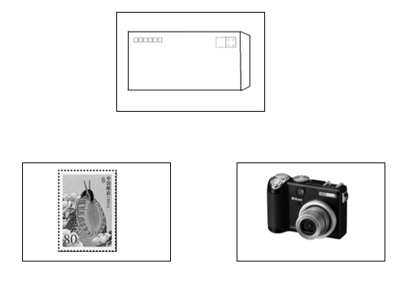
3 Belt Pants Watch
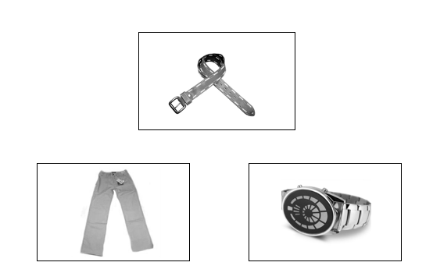
4 Pavilion Bench Building
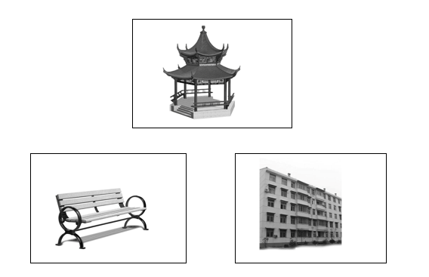

5 Barrel Well Monument
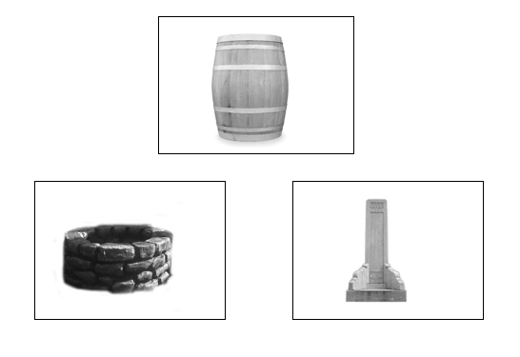
6 Railway Train Bus
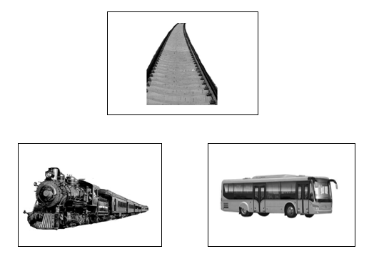
7 Parachute Ship Airplane
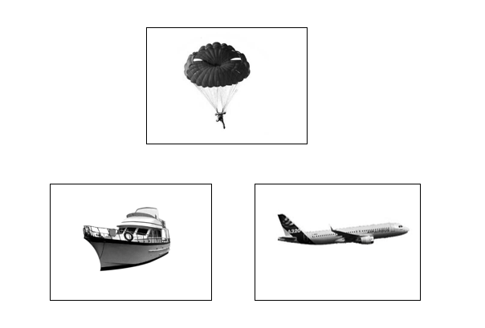
8 Washbasin Flashlight Tap
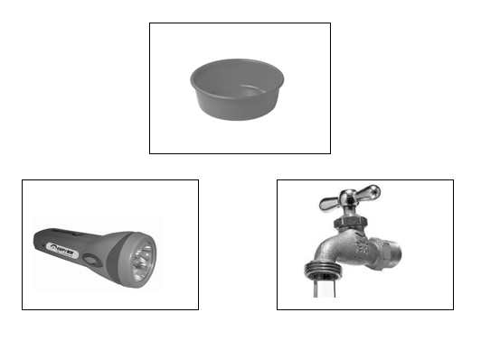
9 Key Steelyard Lock
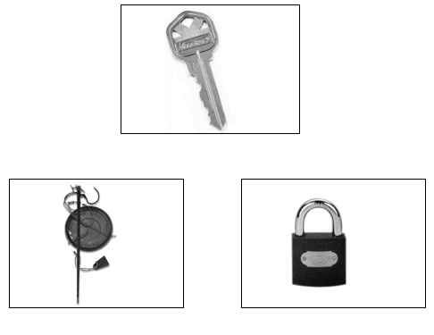
10 Tie Suit Vest
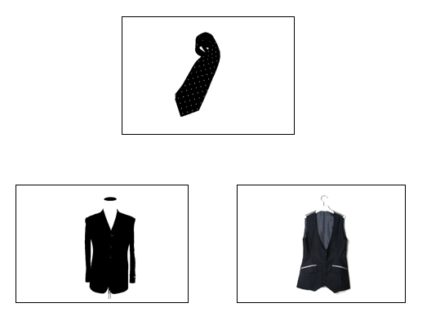
11 Blackboard Desk Tent
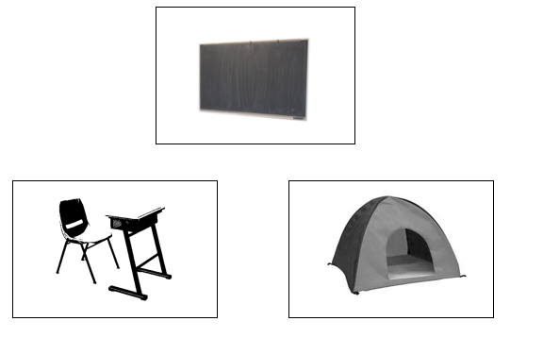
12 Stop sign Bus Airplane
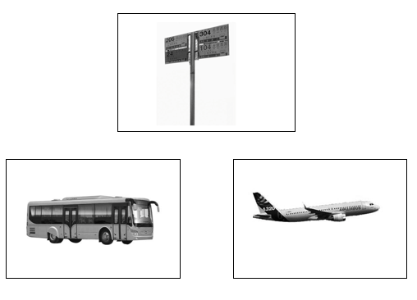
13 Album Lighter Camera
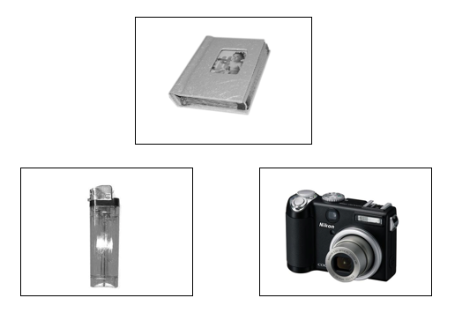

14 Stapler Desk Sound box
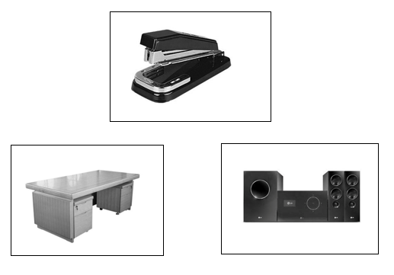
15 Monkey Peach Carrot
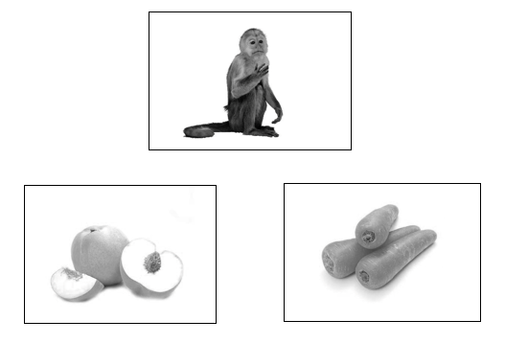
16 Film Video camera Microwave oven
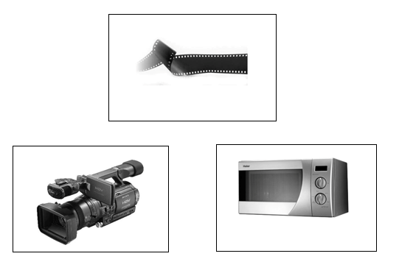
17 Elevator Building Tower
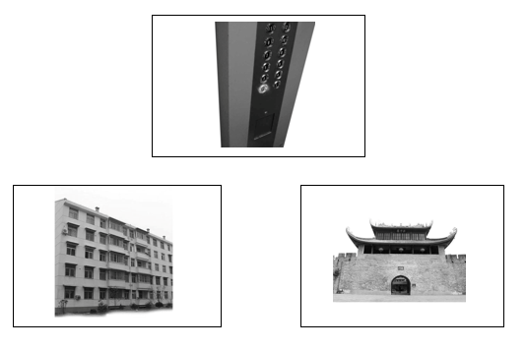

18 Bowl Chopstick Clip
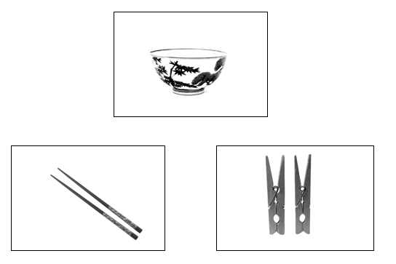
19 Umbrella Pants Rain boots
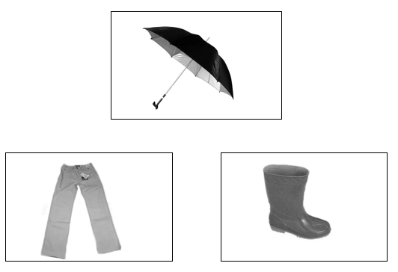
20 Quilt Mask Pillow
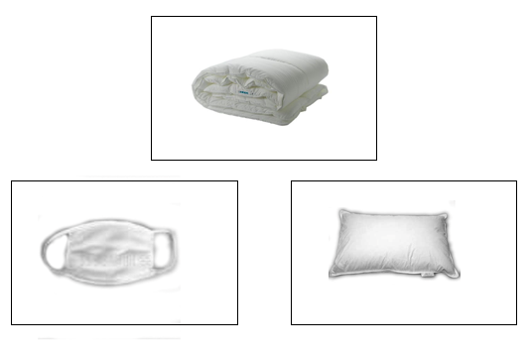
21 Wedding dress Ring Bracelet
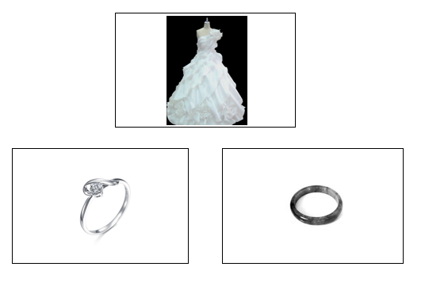

22 Bathtub Hairdryer Tap
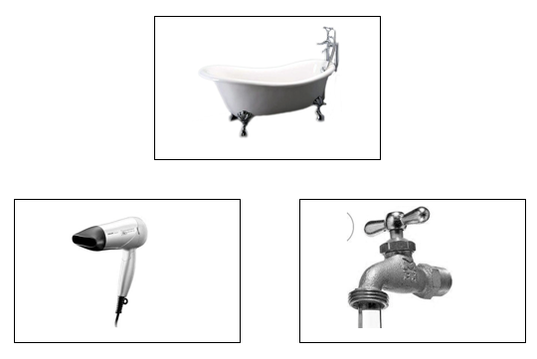
23 Button Pin Bench
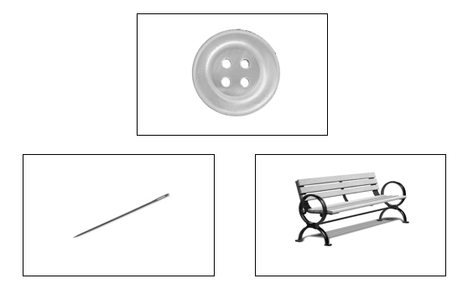
24 Book shelf Desk Parallel bars
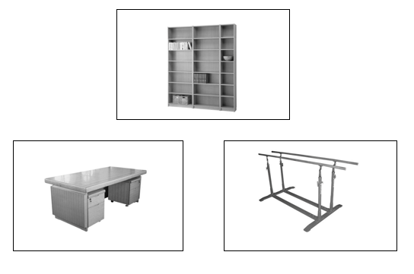
25 Straw Disc Cup
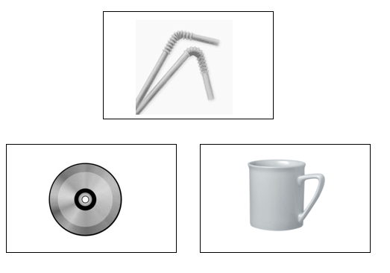

26 Mouse Abacus Computer
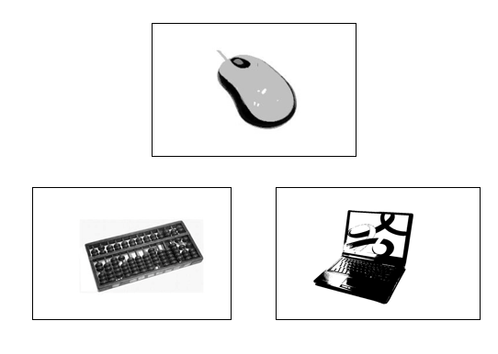
27 Bullet Pistol Longbow
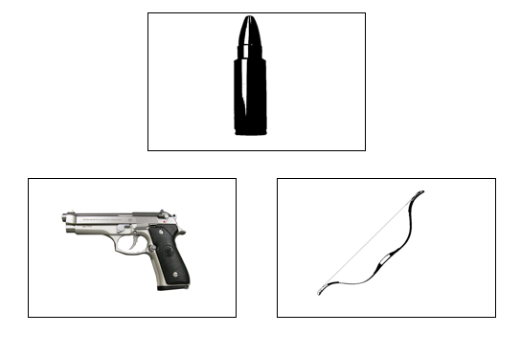
28 TV Flashlight Remote control
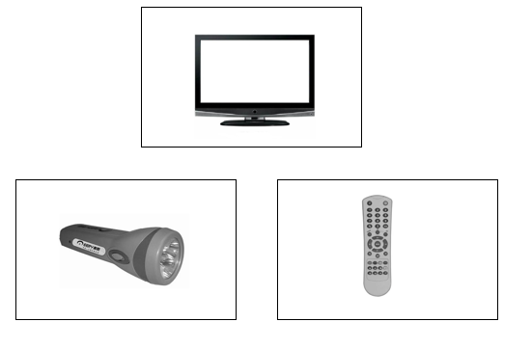

 | PPT—Discarded Items
 | Target | Choice1 | Choice2
1 | Nun | Church | House
2 | Milk | Cow | Bull
3 | Mask | Clown | Mayor
4 | Thimble | Needle | Bobbin
5 | Ticket | Car | Bus
6 | Eskimo | Dome | Building
7 | Pyramid | Palm tree | Pine tree
8 | Windmill | Daffodils | Tulips
9 | Carrot | Lamb | Donkey
10 | Ring | Middle finger | Thumb
11 | Soldier | Church | Castle
12 | Rocket | Pentacle | Sky
13 | Pin | Girl | Baby
14 | Acorn | Donkey | Pig
15 | Sketchpad | Table | Desk
16 | Eskimo | Boat | Kayak

KDT newly developed items
1 Mirroring Drinking Combing
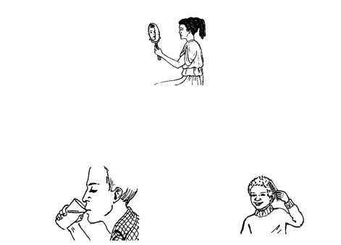
2 Teaching Learning Eating
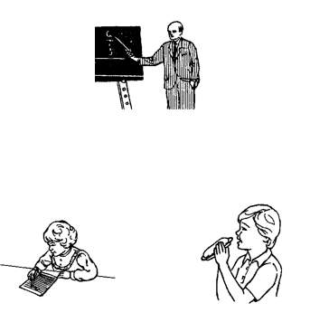
3 Beating Kicking Pulling
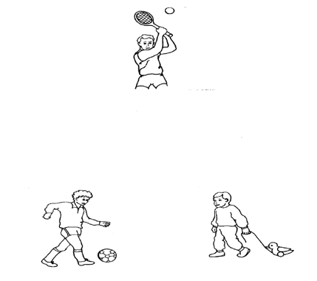

4 Buckling Waving Zipping
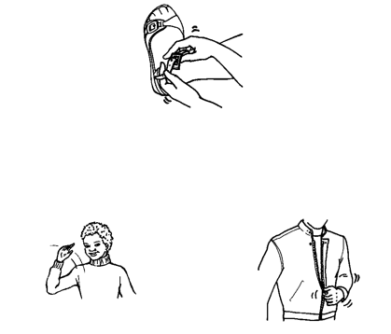
5 Cooking Frying Dropping
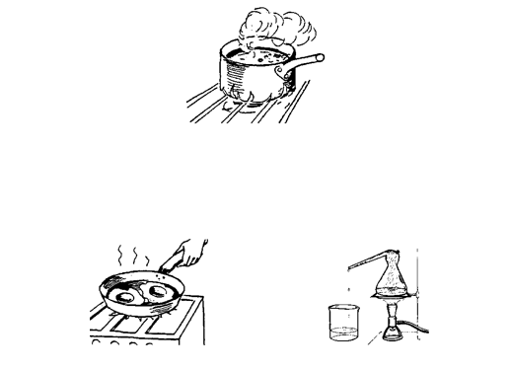
6 Sweeping the floor Pouring trash Playing piano
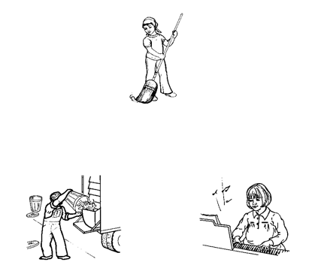
7 Undressing Bathing Falling
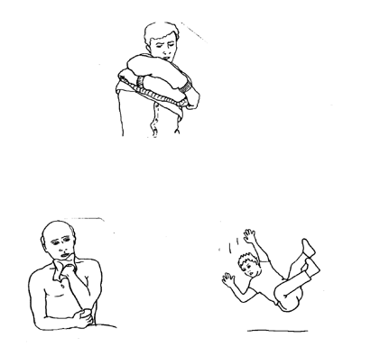

8 Breaking Tearing Packing
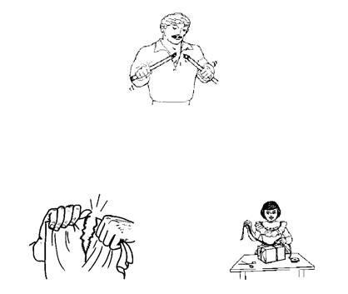
9 Throwing a snowball Flapping bowling Boxing
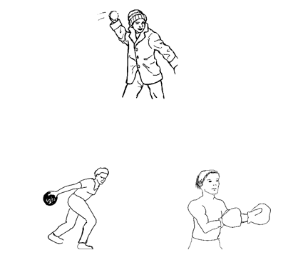
10 Camping Barbecuing Drying clothes
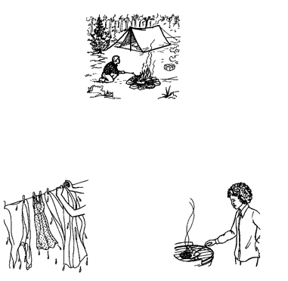
11 Brushing teeth Face Washing Wearing shoes
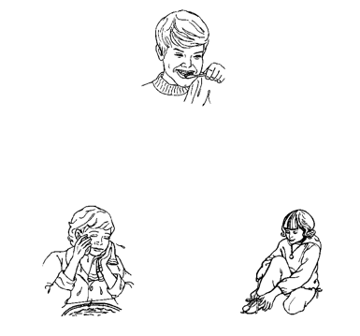

12 Raking Driving Shoveling
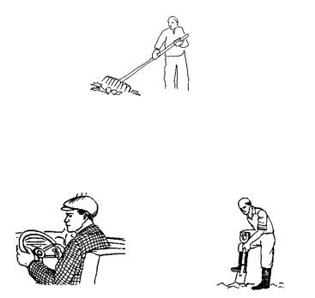
13 Running Singing Walking
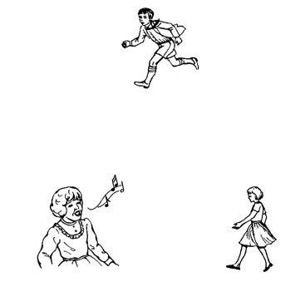
14 Frying Eating Playing baseball
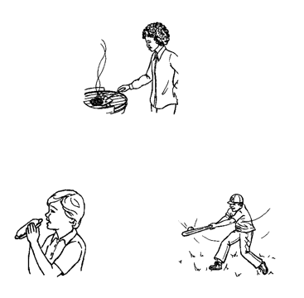
15 Saluting Stepping Kneeling
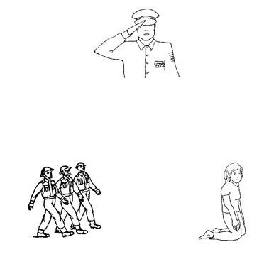
16 Writing Salvaging Erasing
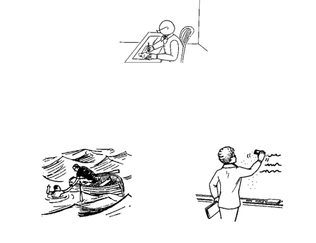
17 Sweating Running Raising a hand
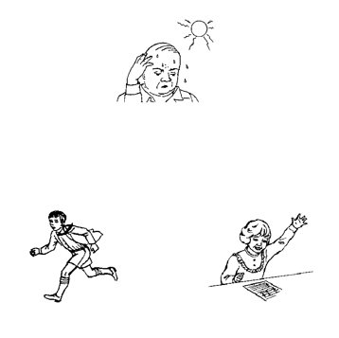
18 Playing piano Dancing Boxing
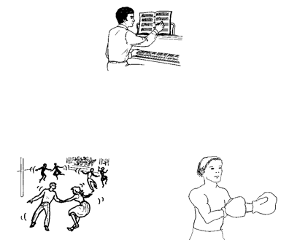
19 Pushing Pulling Plugging
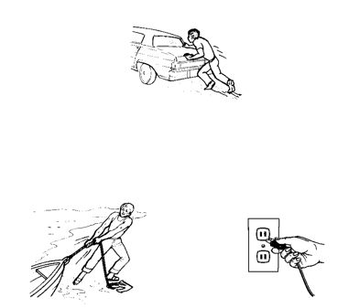
20 Abrading Watering Cutting
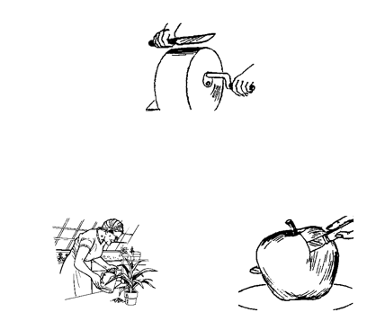
21 Bathing Sleeping Saluting
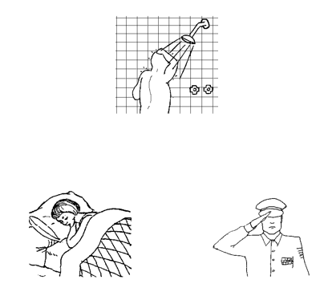
22 Planting Sculpting Picking flowers
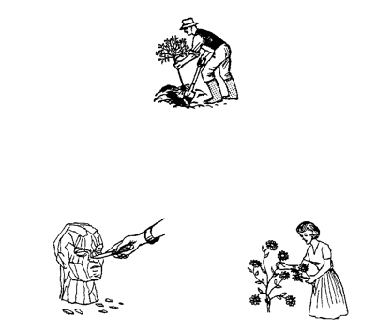
23 Standing Kneeling Eating
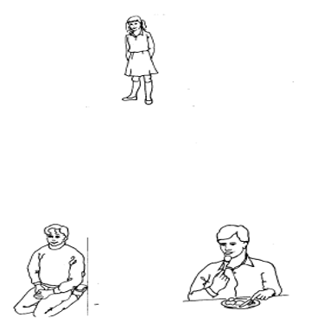

24 Climbing Crying Slipping
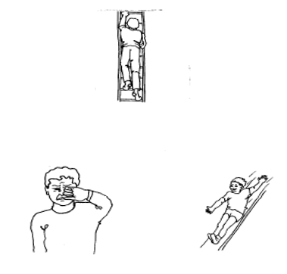
25 Bathing Drying Peeling
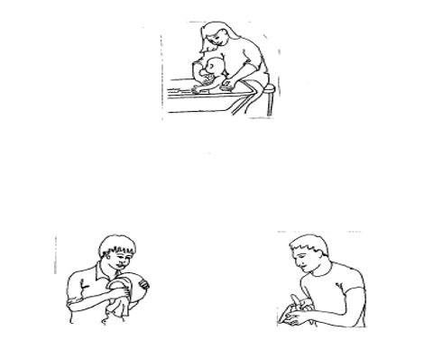
26 Singing Climbing Dancing
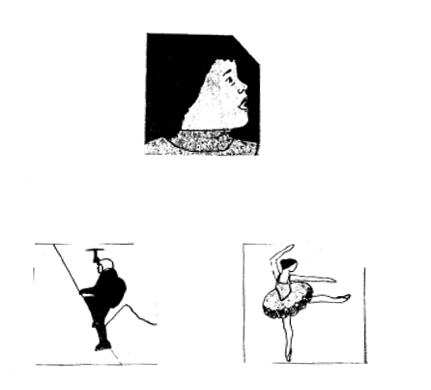

 | KDT-Discarded Items
 | target | choice1 | choice2
1 | Yawning | Jumping | Sleeping
2 | Watering | Pouring | Peeling
3 | Fighting | Shooting | Riding
4 | Washing | Ironing | Knotting
5 | Skiing | Skating | Swimming
6 | Shutting | Opening | Giving
7 | Buying | Robbing | Teaching
8 | Painting | Drawing | Touching
9 | Knocking | Greeting | Cutting
10 | Kissing | Dancing | Running
11 | Falling | Slipping | Bouncing

